**SCMS School of Technology and Management**

**Prathap Nagar, Muttom, Cochin**

|  |  |
| --- | --- |
| **NAME OF THE HOSTING DEPARTMENT** | Department of Management |
| **Name of the Faculty coordinator(s)** | Dr. Deepa Babu K G  Dr. Vilas Nair |
| **Name of the Student coordinator(s)** | Mr. Aadith S Manikandan  Ms. Aleena k Francis |
| **Name of the Event** | Integrated Management Learning Program (IMLP) |
| **Date & Time** | 8-08-2024, THURSDAY |
| **Venue** | SCMS Seminar Hall |
| **Resource Person/ Organisation** | SCMS School of Technology and Management |
| **Participants**  **(Inclusive of participants number):** | Students of MBA B22 (115) |
| **Event description** | The program started at 9:15 AM with a prayer and the judges are from PGDM department. Dr Anju and Sudhir Sudhakaran. All groups were excited to announce their group names and logo. There were total of 14 groups. following are the names of the groups   1. Wave busters 2. Armonia 3. Lumina 4. Spectra 5. The ennead squad 6. Nav amigos 7. Crusaders 8. Nexus 9 9. Valerian   10. Synergist  11. luminaries  12. equilaterals  13. zenith  14. nexarions  Each group got a total time of seven minutes for the presentation and three minutes for the question-answer-session. Both the judges take their time to ask the questions and clear their doubts they were very careful about each and everything including the ppt. Totally it was an interactive session were Sudhir sir asked questions to the audience regarding the presentation. All faculties were there in order to support the students. The program ended at 1 PM and the result will be announced in the next IMLP. |

**Pictures:**

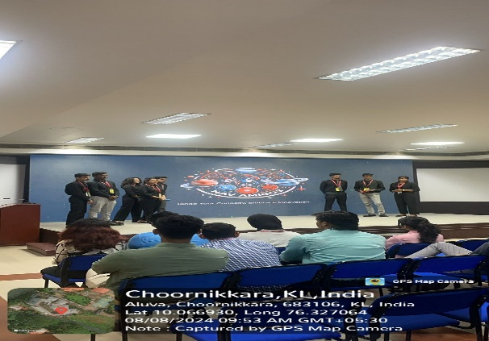

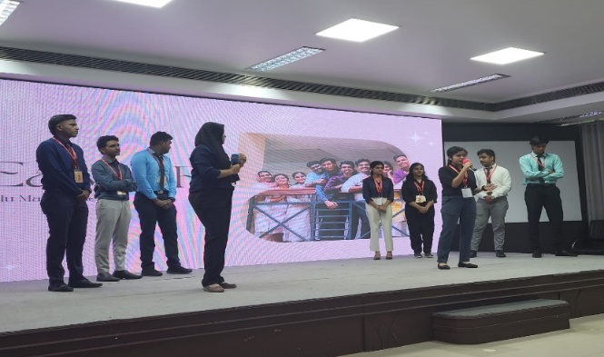

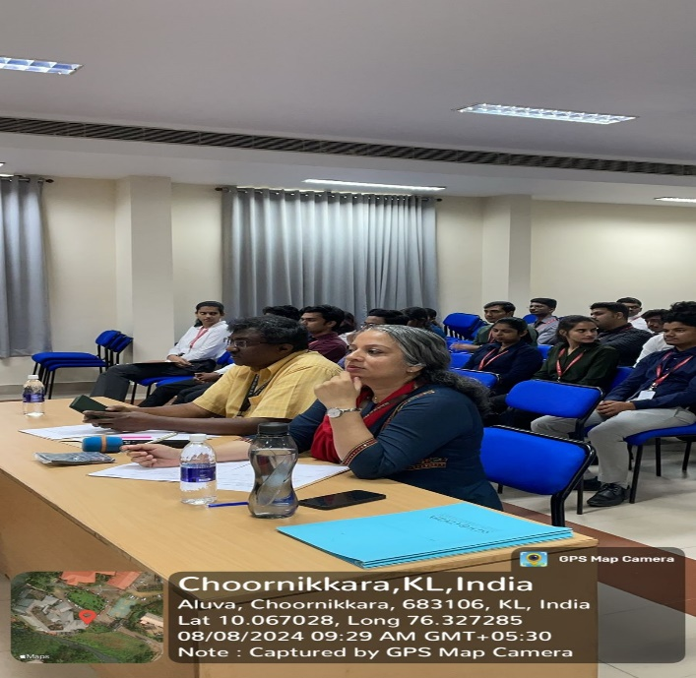

**Signature of the Faculty College Signature of the Principal**

**Event Coordinator Seal**